**Complejidad espacial**

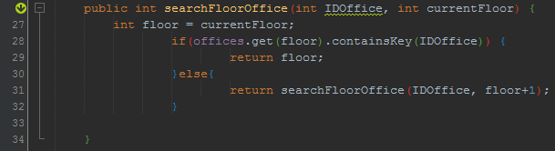1.

|  |  |  |  |
| --- | --- | --- | --- |
| TIPO | Variable | TAMAÑO DE 1 VALOR ATÓMICO | CANTIDD DE VALORES ATÓMICOS |
| ENTRADA | IDOffice  currentFloor | 32  32 | 1  1 |
| AUXILIAR |  | 0 | 0 |
| SALIDA | Floor | 32 | 1 |

𝐶𝑜𝑚𝑝𝑙𝑒𝑗𝑖𝑑𝑑 𝐸. 𝑇𝑜𝑡𝑎𝑙 = 1 + 1 = ∅(1)

𝐶𝑜𝑚𝑝𝑙𝑒𝑗𝑖𝑑𝑎𝑑 𝐸. 𝐴𝑢𝑥𝑖𝑙𝑖𝑎𝑟 = 0 = ∅(0)

𝐶𝑜𝑚𝑝𝑙𝑒𝑗𝑖𝑑𝑎𝑑 𝐸. 𝐴𝑢𝑥𝑖𝑙𝑖𝑎𝑟 + 𝑆𝑎𝑙𝑖𝑑𝑎 = 0 + 1 = ∅(1)

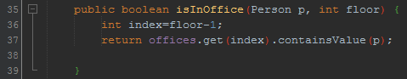2.

|  |  |  |  |
| --- | --- | --- | --- |
| TIPO | Variable | TAMAÑO DE 1 VALOR ATÓMICO | CANTIDD DE VALORES ATÓMICOS |
| ENTRADA | p  floor | 128  32 | 1  1 |
| AUXILIAR | index | 32 | 1 |
| SALIDA | Offices.get(index).containsValue(p) | 64 | 1 |

𝐶𝑜𝑚𝑝𝑙𝑒𝑗𝑖𝑑𝑑 𝐸. 𝑇𝑜𝑡𝑎𝑙 = 4 = ∅(4)

𝐶𝑜𝑚𝑝𝑙𝑒𝑗𝑖𝑑𝑎𝑑 𝐸. 𝐴𝑢𝑥𝑖𝑙𝑖𝑎𝑟 = 1 = ∅(1)

𝐶𝑜𝑚𝑝𝑙𝑒𝑗𝑖𝑑𝑎𝑑 𝐸. 𝐴𝑢𝑥𝑖𝑙𝑖𝑎𝑟 + 𝑆𝑎𝑙𝑖𝑑𝑎 = 1 + 1 = ∅(1)